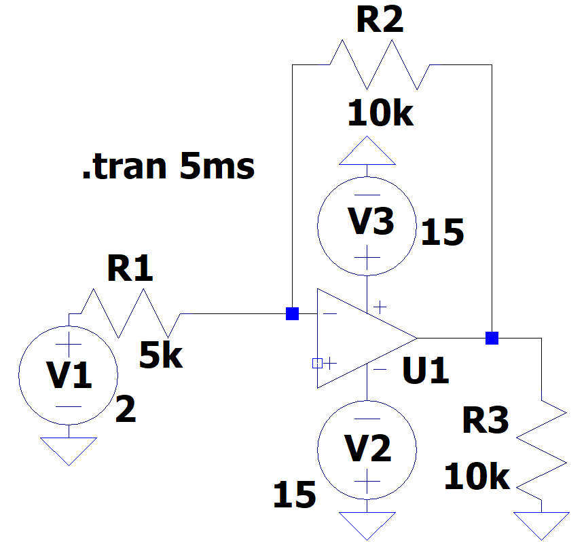

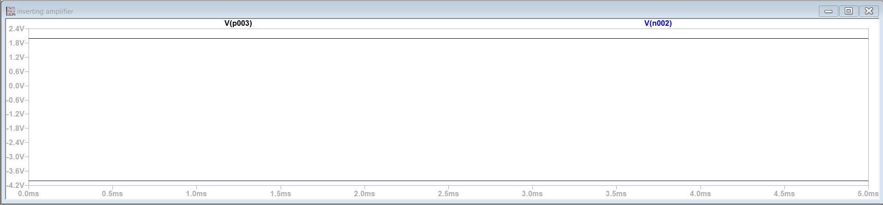

Inverting Amplifier

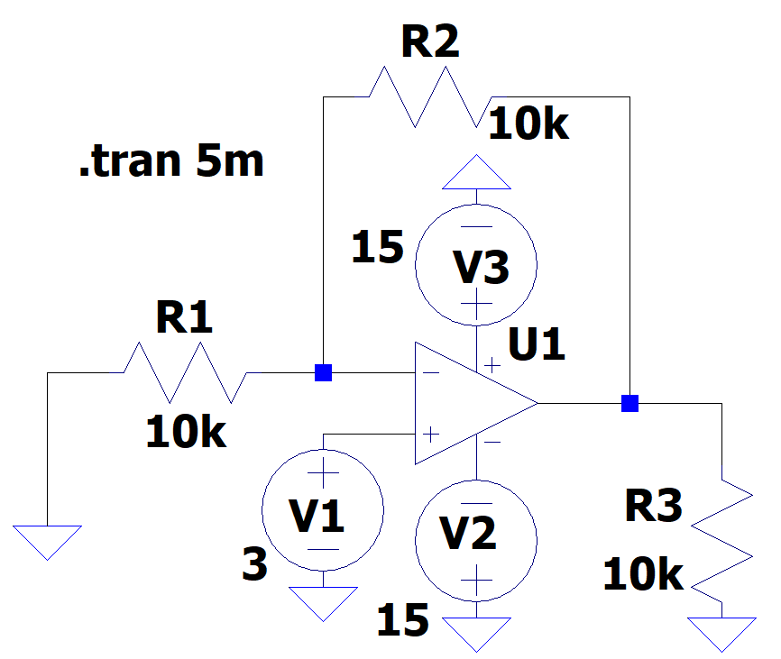

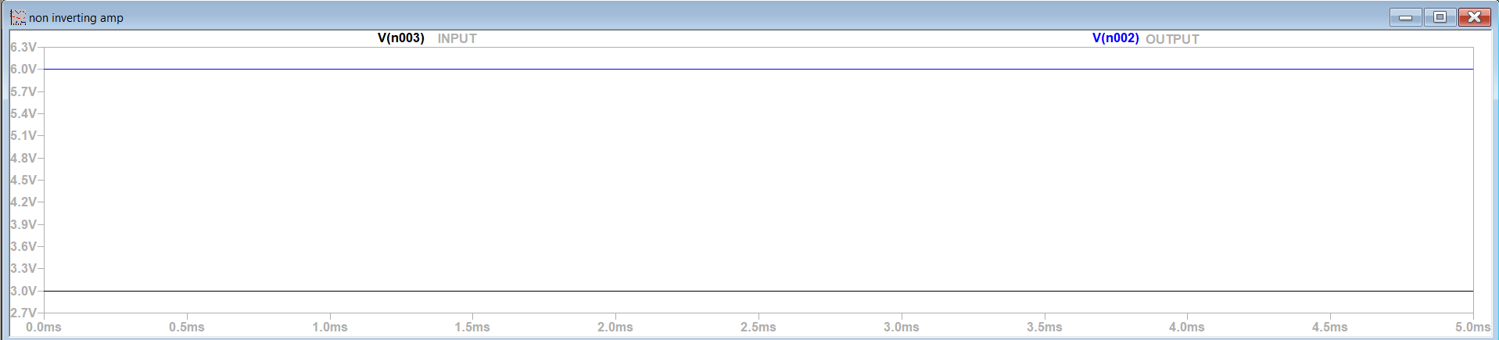

Non-Inverting Amplifier

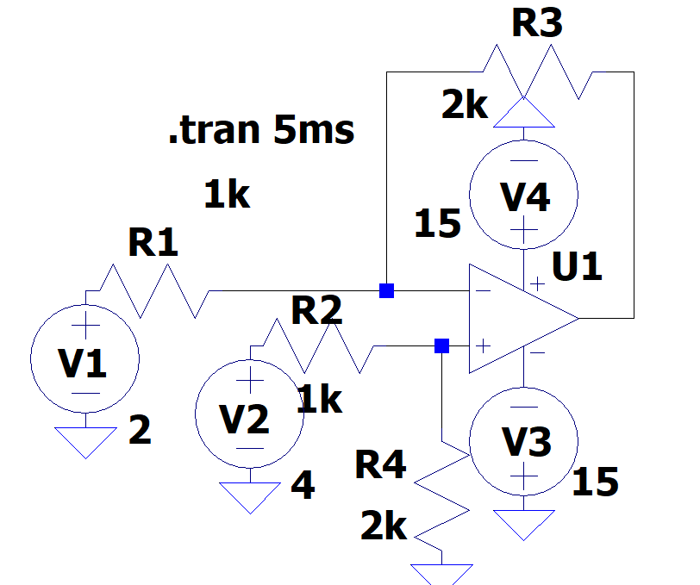

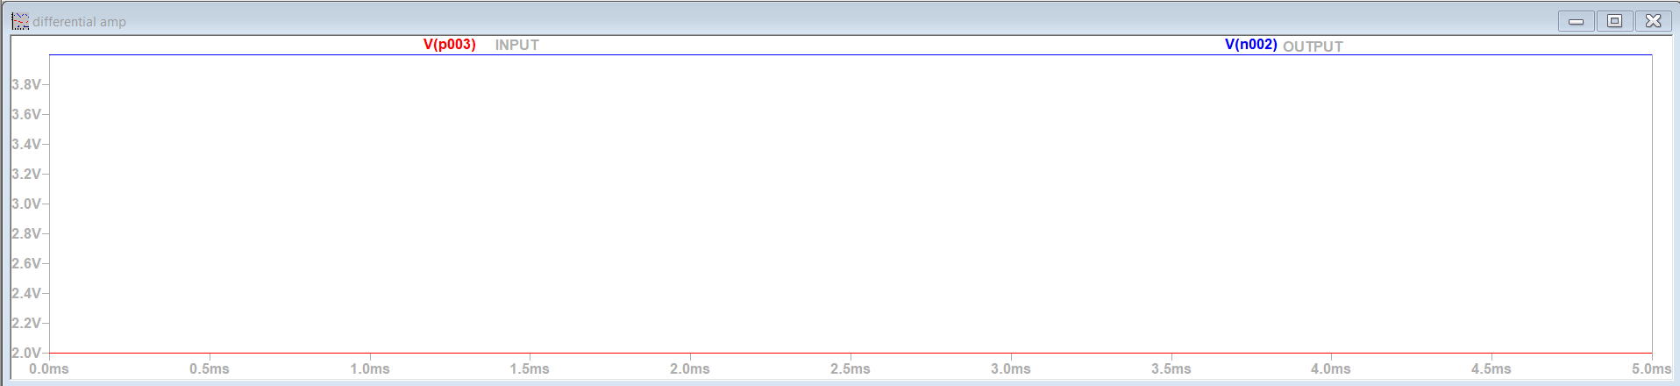

DIFFERENTIAL AMPLIFIER

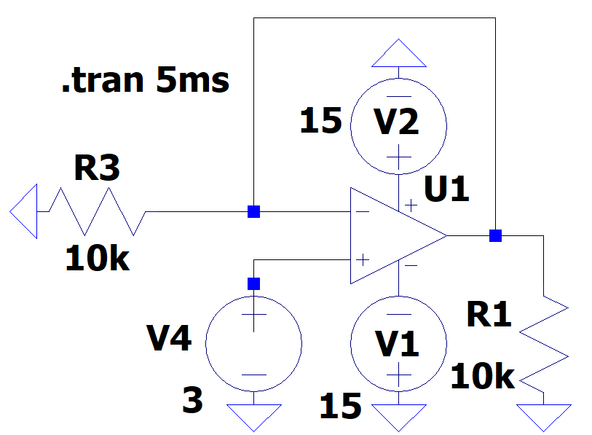

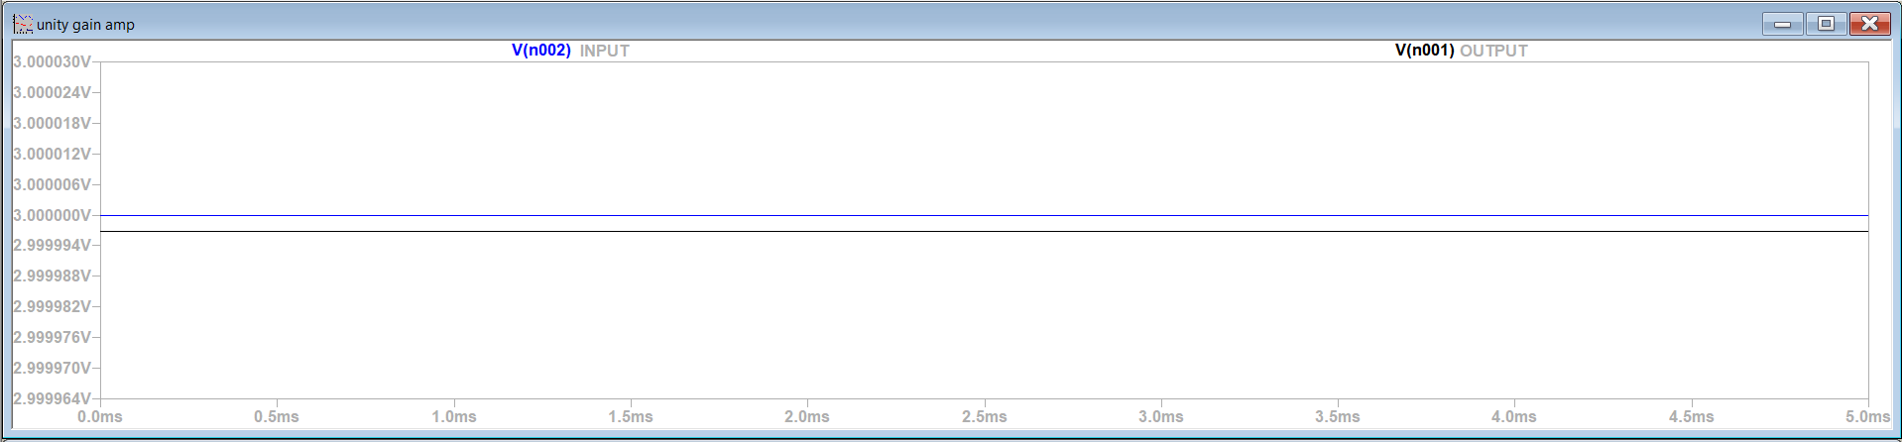

UNITY GAIN AMPLIFIER

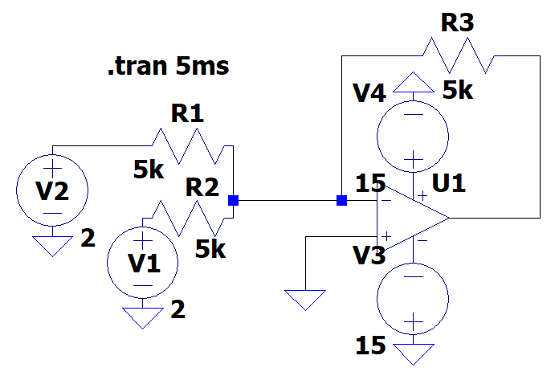

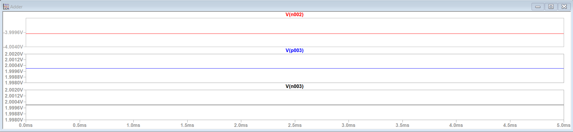

ADDER

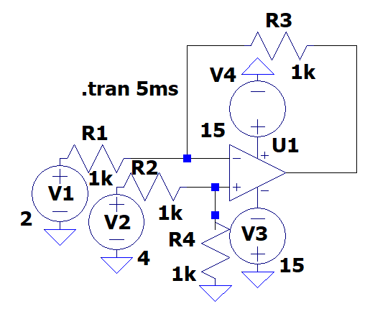

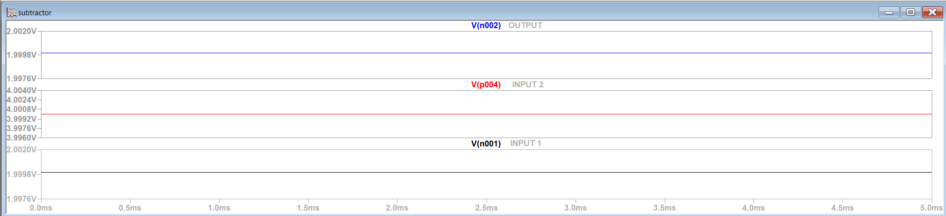

SUBTRACTOR

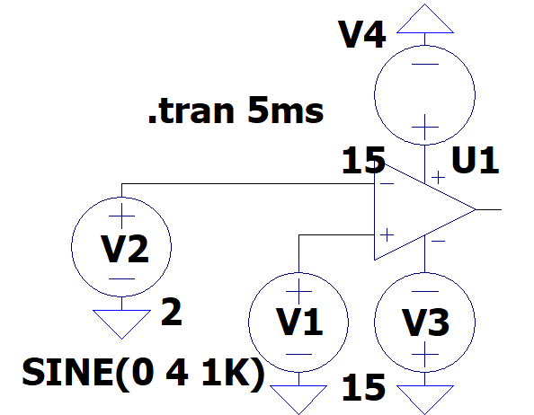

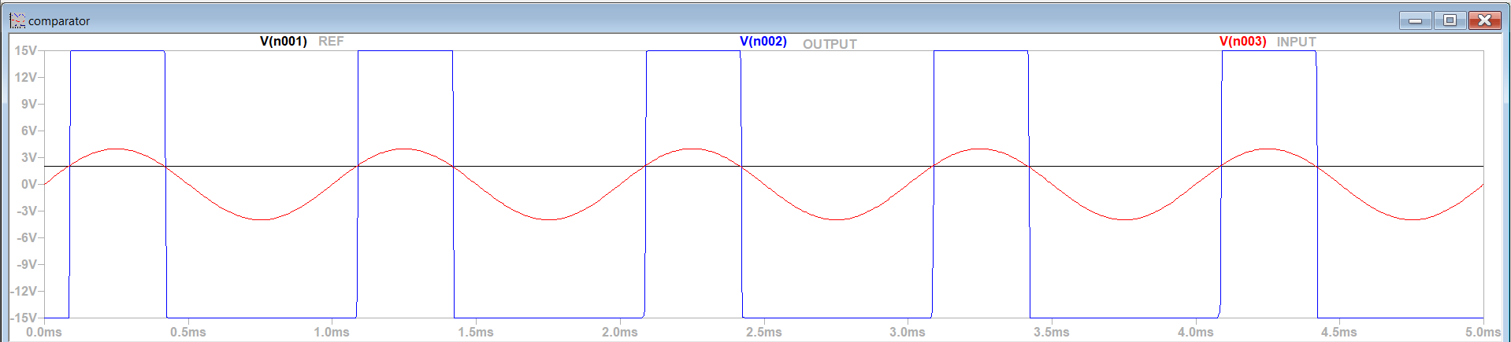

COMPARATOR

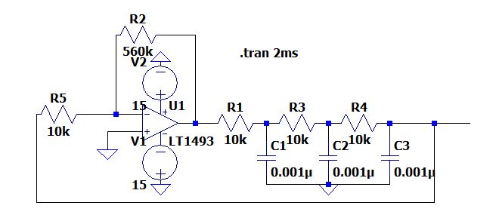

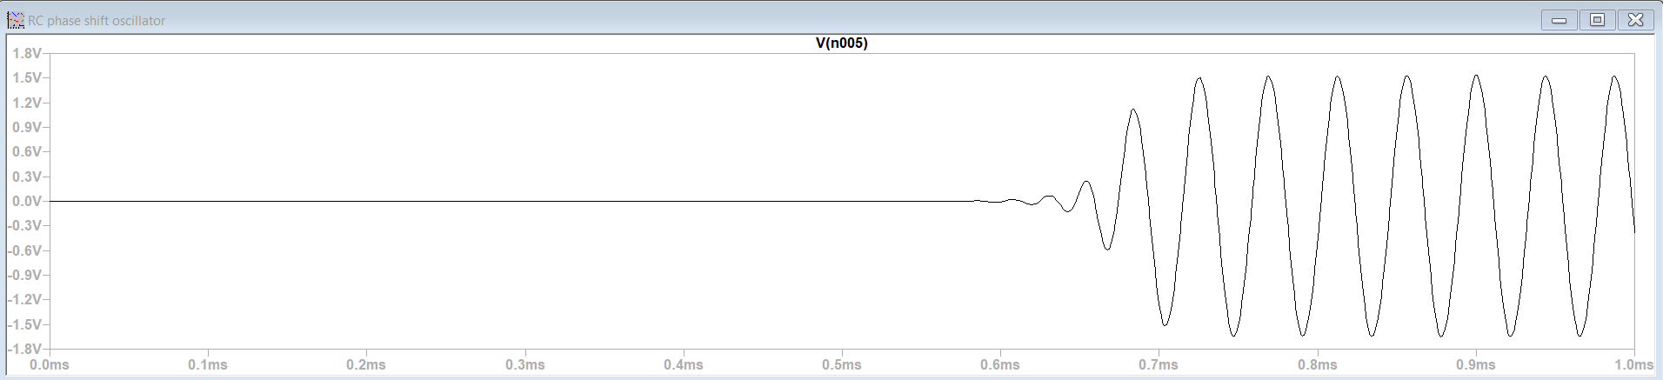

RC PHASE SHIFT OSCILLATOR

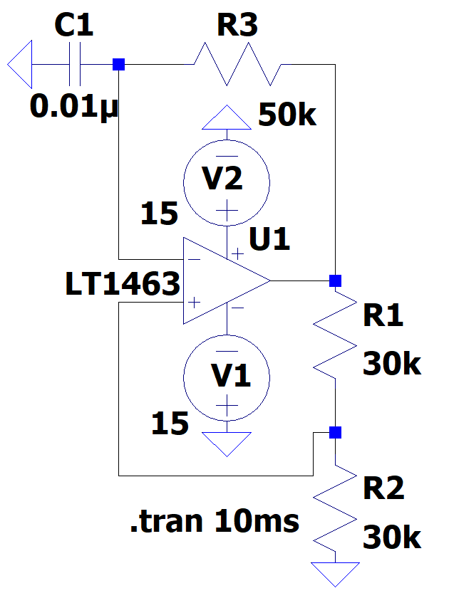

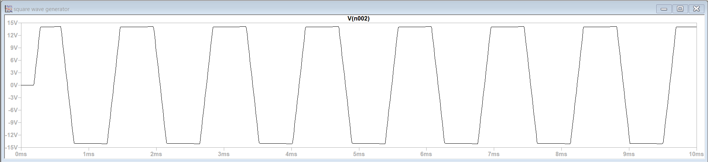

SQUARE WAVE GENERATOR

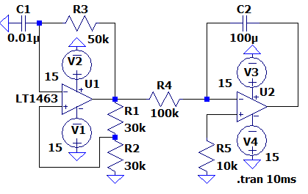

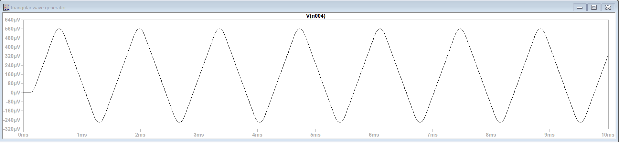

TRIANGULAR WAVE GENERATOR

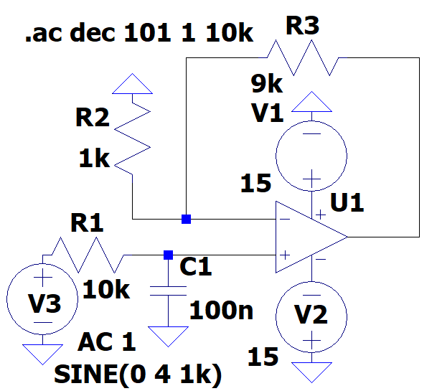

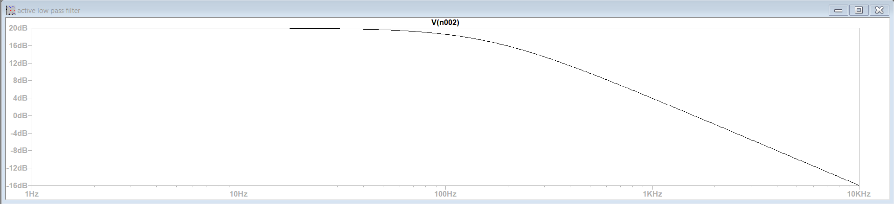

LOW PASS FILTER

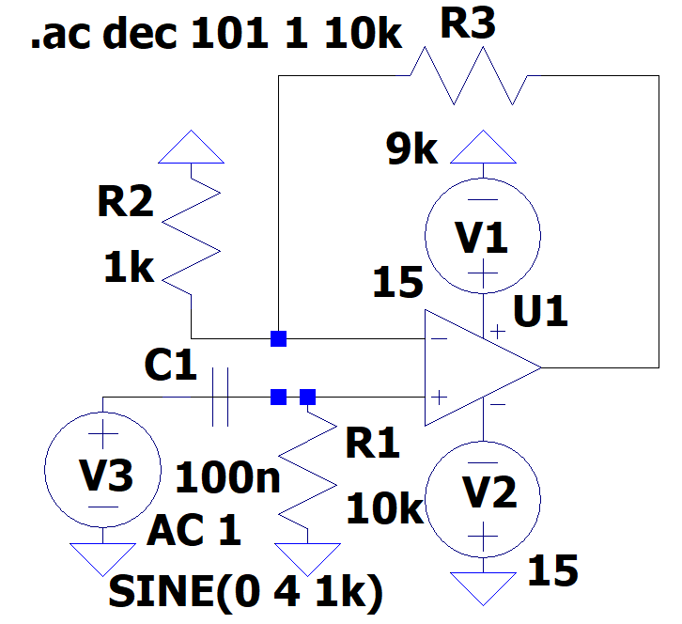

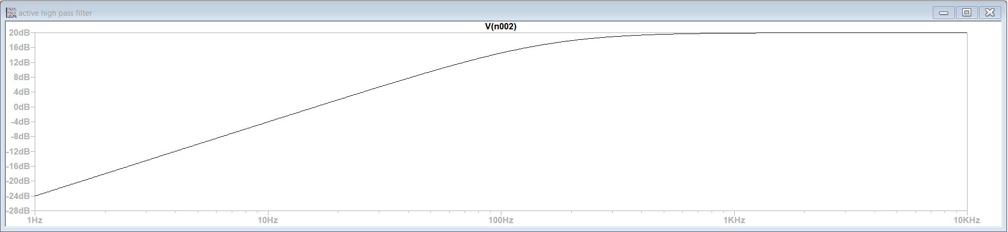

HIGH PASS FILTER

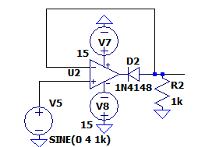 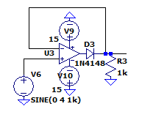

POSITIVE CLIPPER NEGATIVE CLIPPER

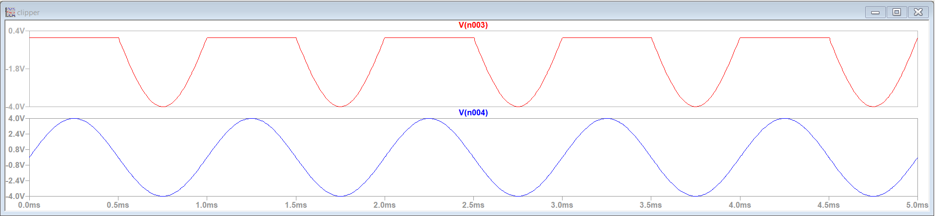

POSITIVE CLIPPER

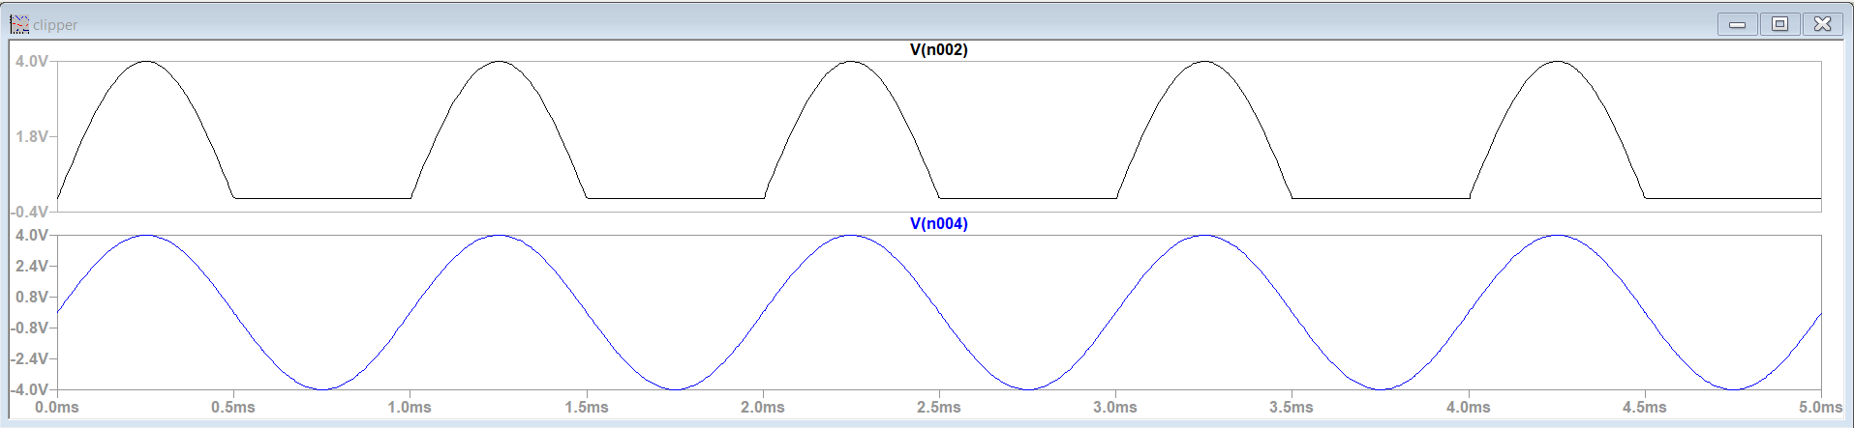

NEGATIVE CLIPPER